Департамент профессионального образования Томской области

ОГБПОУ «ТОМСКИЙ ТЕХНИКУМ ИНФОРМАЦИОННЫХ ТЕХНОЛОГИЙ»

Отчет по лабораторной работе
Дисциплина: Инженерно – техническая поддержка сопровождения информационных систем.
Практическая работа №6.

Выполнил: студенты группы 682 Бихтеев Петр Вячеславович, Вадругина Дарья Дмитриевна
Принял: преподаватель Маюнова Анна Юрьевна

Томск 2021
Оглавление
ОГБПОУ «ТОМСКИЙ ТЕХНИКУМ ИНФОРМАЦИОННЫХ ТЕХНОЛОГИЙ» 1
Окно MainWindow (Окно авторизации): 3
Окно AdminWindow (Окно администратора): 6
Окно WaiterWindow (Окно официанта): 37
Окно ReportWaiter (Окно отчета официанта): 49
Окно CookWindow (Окно повара): 51
Класс Helper: 54
Ссылка на GitHub: 55

Окно MainWindow (Окно авторизации):
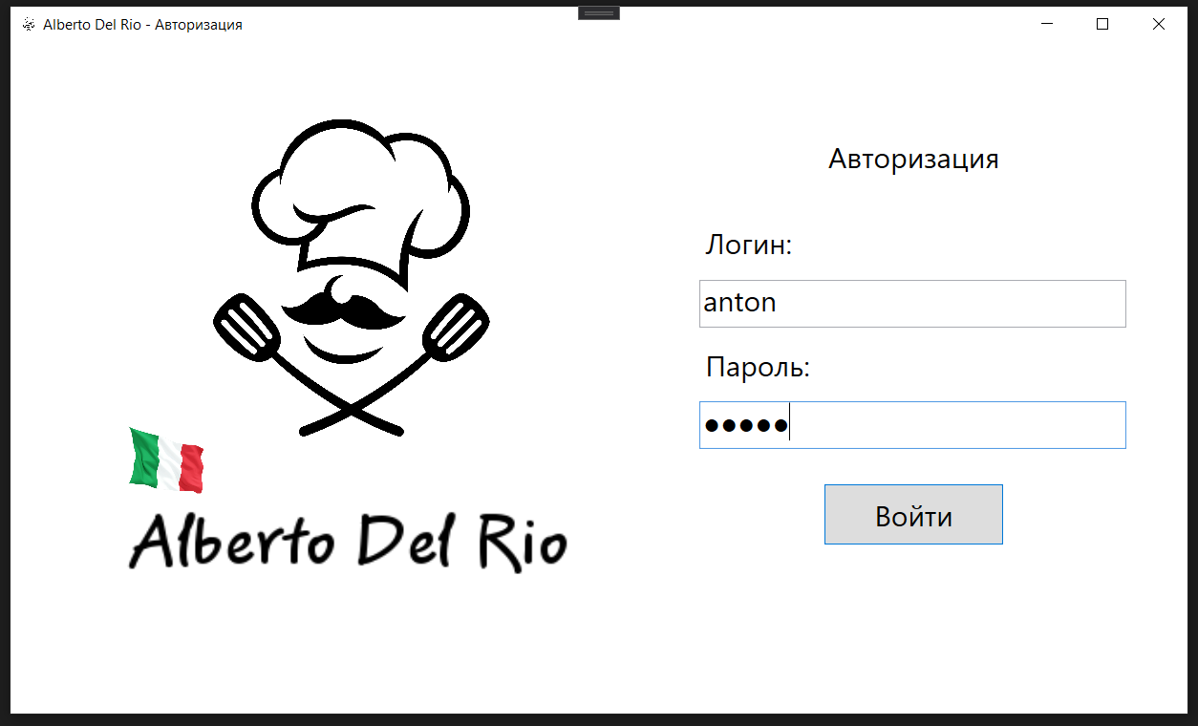
Код:
using System;
using System.Collections.Generic;
using System.Linq;
using System.Media;
using System.Text;
using System.Threading.Tasks;
using System.Windows;
using System.Windows.Controls;
using System.Windows.Data;
using System.Windows.Documents;
using System.Windows.Input;
using System.Windows.Media;
using System.Windows.Media.Imaging;
using System.Windows.Navigation;
using System.Windows.Shapes;

namespace KAFE
{
/// <summary>
/// Логика взаимодействия для MainWindow.xaml
/// </summary>
public partial class MainWindow : Window
{
public MainWindow()
{
InitializeComponent();
logintxt.Focus();
}

private void Grid_MouseDown(object sender, MouseButtonEventArgs e)
{
if(e.LeftButton == MouseButtonState.Pressed)
{
DragMove();
}
}

private void Loginbtn_Click(object sender, RoutedEventArgs e)
{
if (logintxt.Text == "" || passwordpsw.Password == "")
{
MessageBox.Show("Пустое поле логина/пароля!", "Предупреждение", MessageBoxButton.OK,MessageBoxImage.Information);
}
else
{
var todaysDate = new DateTime(DateTime.Today.Year, DateTime.Today.Month, DateTime.Today.Day);
var user = Helper.GetContext().Users.FirstOrDefault(x => x.Login == logintxt.Text && x.Password == passwordpsw.Password);
if (user == null)
{
MessageBox.Show("Такого пользователя не существует!", "Предупреждение", MessageBoxButton.OK, MessageBoxImage.Information);
logintxt.Text = "";
passwordpsw.Password = "";
logintxt.Focus();
}
else if (user.ID_Status == 2)
{
MessageBox.Show("Этот сотрудник уволен!", "Предупреждение", MessageBoxButton.OK, MessageBoxImage.Information);
logintxt.Text = "";
passwordpsw.Password = "";
logintxt.Focus();
}
else
{
string userinfo = user.LastName + " " + user.FirstName.Substring(0, 1) + ". " + user.MiddleName.Substring(0, 1) + ".";
Helper.ID_user = user.ID_User;
if (user.ID_Role == 1)
{
MessageBox.Show("Вы вошли как Администратор!", "Информация", MessageBoxButton.OK, MessageBoxImage.Information);
AdminWindow adminWindow = new AdminWindow();
adminWindow.Title = "Администратор - " + userinfo;
adminWindow.Show();
this.Close();
}
if (user.ID_Role == 2)
{
if (Helper.GetContext().WorkShift.Where(x=>x.ID_User==Helper.ID_user&&x.DateShift==todaysDate).FirstOrDefault() !=null)
{
MessageBox.Show("Вы вошли как Официант!", "Информация", MessageBoxButton.OK, MessageBoxImage.Information);
WaiterWindow waiterWindow = new WaiterWindow();
waiterWindow.Title = "Официант - " + userinfo;
waiterWindow.Show();
this.Close();
}
else
{
MessageBox.Show("Ваша смена сегодня не назначена!", "Информация", MessageBoxButton.OK, MessageBoxImage.Information);
}
}
if (user.ID_Role == 3)
{
if (Helper.GetContext().WorkShift.Where(x => x.ID_User == Helper.ID_user && x.DateShift == todaysDate).FirstOrDefault() != null)
{
MessageBox.Show("Вы вошли как Повар!", "Информация", MessageBoxButton.OK, MessageBoxImage.Information);
CookWindow cookWindow = new CookWindow();
cookWindow.Title = "Повар - " + userinfo;
cookWindow.Show();
this.Close();
}
else
{
MessageBox.Show("Ваша смена сегодня не назначена!", "Информация", MessageBoxButton.OK, MessageBoxImage.Information);
}
}
}
}
}
}
}

Окно AdminWindow (Окно администратора):
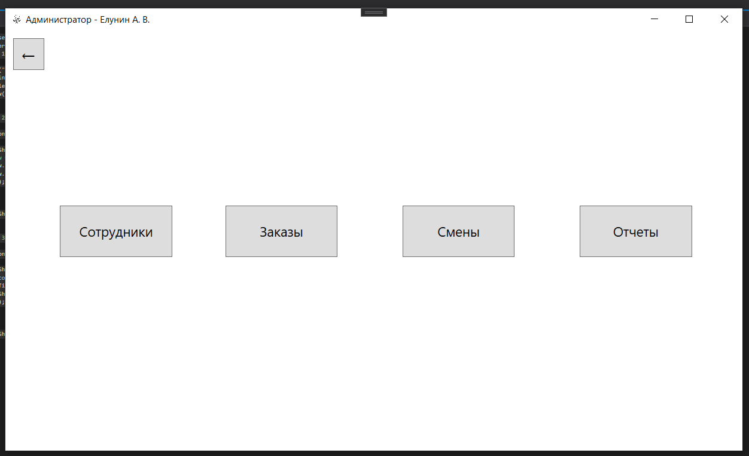
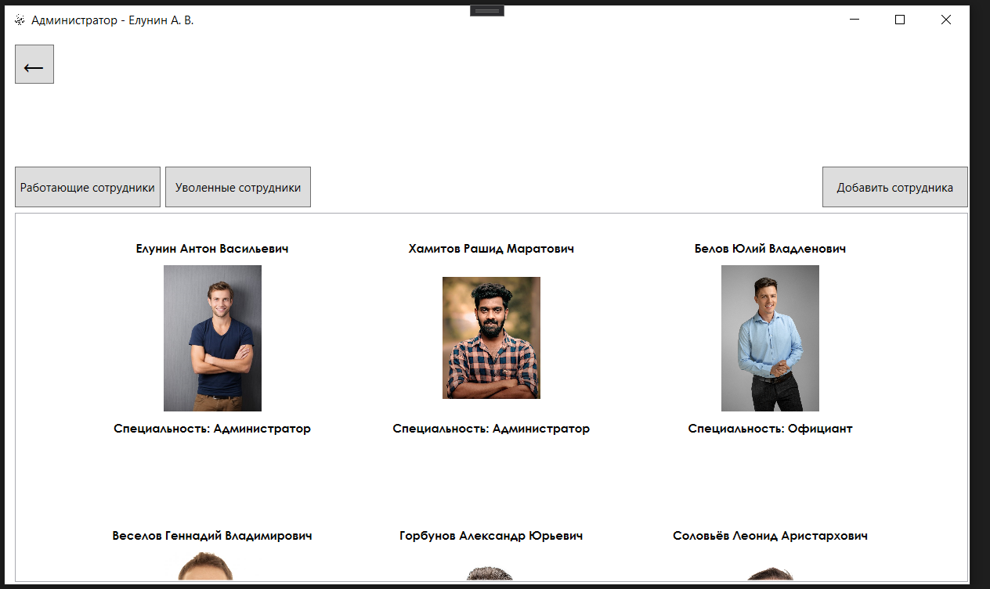
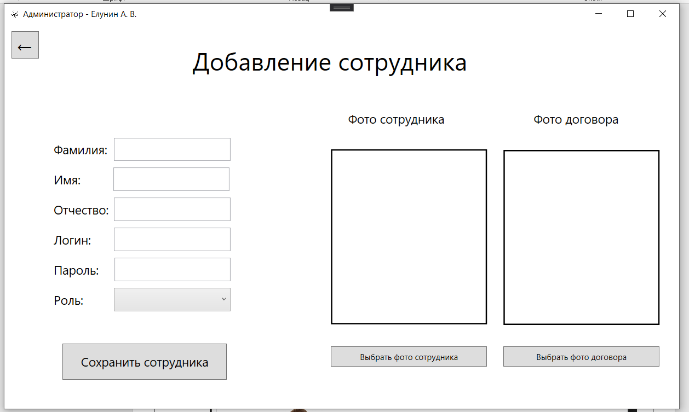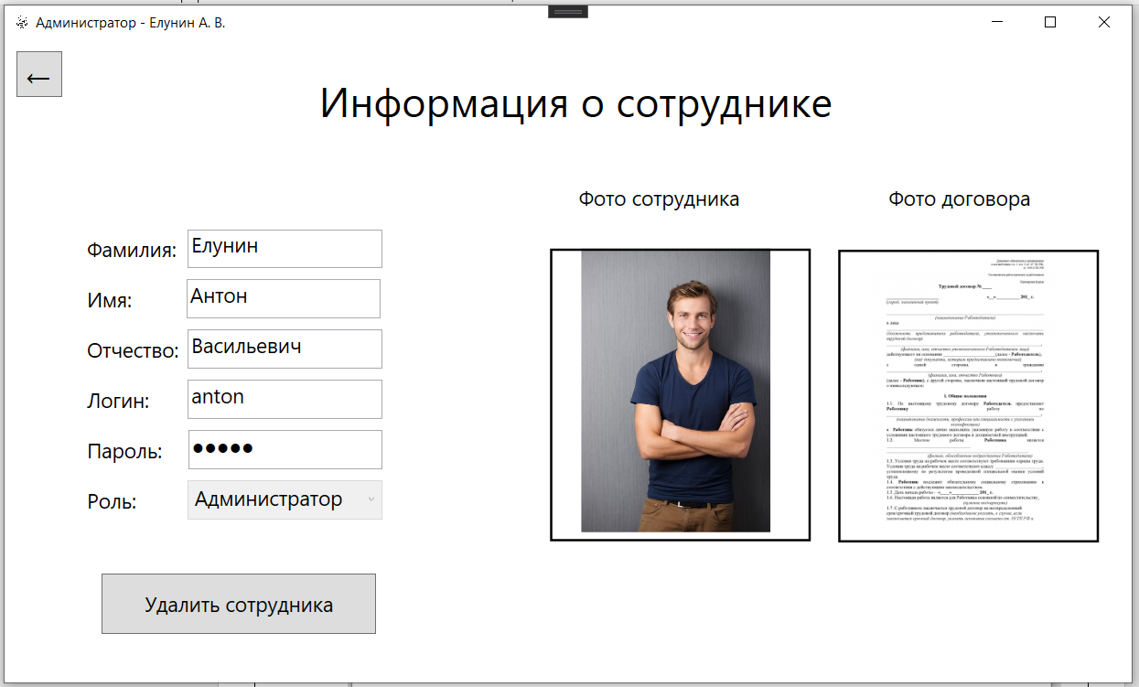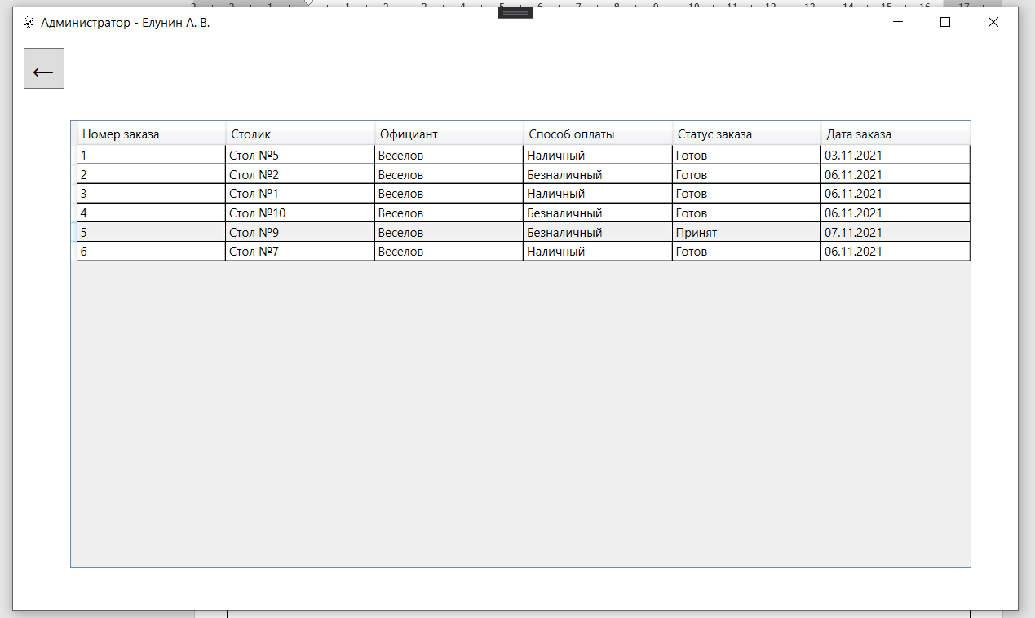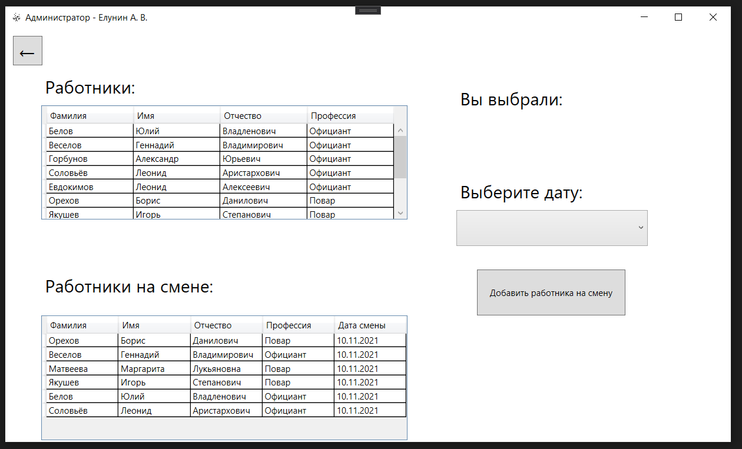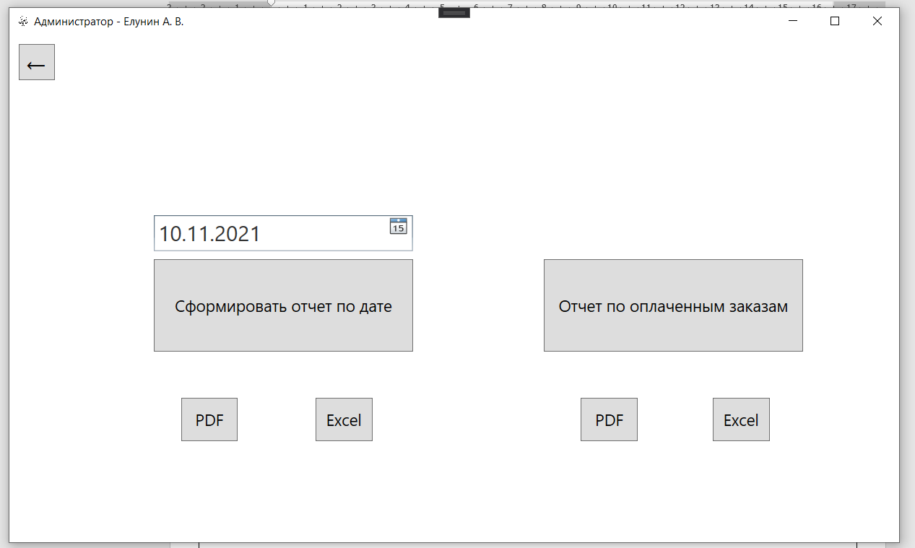
Код:
using Microsoft.Win32;
using System;
using System.Collections.Generic;
using System.IO;
using System.Linq;
using System.Text;
using System.Threading.Tasks;
using System.Windows;
using System.Windows.Controls;
using System.Windows.Data;
using System.Windows.Documents;
using System.Windows.Input;
using System.Windows.Media;
using System.Windows.Media.Imaging;
using System.Windows.Shapes;
using Word = Microsoft.Office.Interop.Word;
using Excel = Microsoft.Office.Interop.Excel;

namespace KAFE
{
/// <summary>
/// Логика взаимодействия для AdminWindow.xaml
/// </summary>
public partial class AdminWindow : Window
{
public AdminWindow()
{
InitializeComponent();
//gridosnova.Visibility = Visibility.Visible;
rolecombo.ItemsSource = Helper.GetContext().RoleUsers.ToList();
listviewuser.ItemsSource = Helper.GetContext().Users.Where(x => x.ID_Status == 1).ToList();
datagridorder.ItemsSource = Helper.GetContext().Orders.ToList();
combofood.ItemsSource = Helper.GetContext().Food.ToList();
combotypefood.ItemsSource = Helper.GetContext().TypeFood.ToList();
var todaysDate = new DateTime(DateTime.Today.Year, DateTime.Today.Month, DateTime.Today.Day);
combosmena.Items.Add(todaysDate.AddDays(1).ToShortDateString());
combosmena.Items.Add(todaysDate.AddDays(2).ToShortDateString());
combosmena.Items.Add(todaysDate.AddDays(3).ToShortDateString());
combosmena.Items.Add(todaysDate.AddDays(4).ToShortDateString());
combosmena.Items.Add(todaysDate.AddDays(5).ToShortDateString());
}
byte[] personalphotobyte = null;
byte[] contractphotobyte = null;
int idusersmena = 0;

private void addpersonalphoto_Click(object sender, RoutedEventArgs e)
{
try
{
string imageLoc = "";
OpenFileDialog dld = new OpenFileDialog();
dld.Filter = "JPG Files (*.jpg)|*.jpg|PNG Files (*.png)|*.png|JPEG Files (*.jpeg)|*.jpeg";
dld.Title = "Выберите фотографию пользователя";
bool? result = dld.ShowDialog();
if (result == true)
{
imageLoc = dld.FileName.ToString();
photopersonal.Source = new BitmapImage(new Uri(imageLoc));
FileStream fs = new FileStream(imageLoc, FileMode.Open, FileAccess.Read);
BinaryReader br = new BinaryReader(fs);
personalphotobyte = br.ReadBytes((int)fs.Length);
}
}
catch (Exception ex)
{
MessageBox.Show(ex.Message);
}
}

private void addcontractphoto_Click(object sender, RoutedEventArgs e)
{
try
{
OpenFileDialog dld = new OpenFileDialog();
dld.Filter = "JPG Files (*.jpg)|*.jpg|PNG Files (*.png)|*.png|JPEG Files (*.jpeg)|*.jpeg";
dld.Title = "Выберите фотографию пользователя";
bool? result = dld.ShowDialog();
if (result == true)
{
string imageLoc;
imageLoc = dld.FileName.ToString();
photocontract.Source = new BitmapImage(new Uri(imageLoc));
FileStream fs = new FileStream(imageLoc, FileMode.Open, FileAccess.Read);
BinaryReader br = new BinaryReader(fs);
contractphotobyte = br.ReadBytes((int)fs.Length);
}
}
catch (Exception ex)
{
MessageBox.Show(ex.Message);
}
}

private void saveadduser_Click(object sender, RoutedEventArgs e)
{
if (lastnametxt.Text == "" || nametxt.Text == "" || middlenametxt .Text == "" || logintxt.Text == "" || passwordtxt.Password == "" || rolecombo.Text == "" || personalphotobyte == null || contractphotobyte == null)
{
MessageBox.Show("Пустые значения!", "Предупреждение", MessageBoxButton.OK, MessageBoxImage.Information);
}
else
{
var user = Helper.GetContext().Users.FirstOrDefault(x => x.Login == logintxt.Text);
if (user != null)
{
MessageBox.Show("Пользователь с таким логином уже есть в системе!", "Предупреждение", MessageBoxButton.OK, MessageBoxImage.Information);
}
else
{
var role = Helper.GetContext().RoleUsers.FirstOrDefault(x => x.RoleName == rolecombo.Text);
Users users = new Users
{
LastName = lastnametxt.Text,
FirstName = nametxt.Text,
MiddleName = middlenametxt.Text,
Login = logintxt.Text,
Password = passwordtxt.Password,
ID_Status = 1,
ID_Role = role.ID_Role,
PersonalPhoto = personalphotobyte,
ContractPhoto = contractphotobyte
};
Helper.GetContext().Users.Add(users);
Helper.GetContext().SaveChanges();
MessageBox.Show("Пользователь успешно добавлен", "Информация", MessageBoxButton.OK, MessageBoxImage.Information);
lastnametxt.Text = "";
nametxt.Text = "";
middlenametxt.Text = "";
logintxt.Text = "";
passwordtxt.Password = "";
rolecombo.Text = "";
personalphotobyte = null;
contractphotobyte = null;
photocontract.Source = null;
photopersonal.Source = null;
}
}
}

private void dropphotopersonal_Drop(object sender, DragEventArgs e)
{
if (e.Data.GetDataPresent(DataFormats.FileDrop))
{
string[] files = (string[])e.Data.GetData(DataFormats.FileDrop);
string imageLoc = System.IO.Path.GetFullPath(files[0]).ToString();
photopersonal.Source = new BitmapImage(new Uri(imageLoc));
FileStream fs = new FileStream(imageLoc, FileMode.Open, FileAccess.Read);
BinaryReader br = new BinaryReader(fs);
personalphotobyte = br.ReadBytes((int)fs.Length);
}
}

private void dropphotocontract_Drop(object sender, DragEventArgs e)
{
string[] files = (string[])e.Data.GetData(DataFormats.FileDrop);
string imageLoc = System.IO.Path.GetFullPath(files[0]).ToString();
photocontract.Source = new BitmapImage(new Uri(imageLoc));
FileStream fs = new FileStream(imageLoc, FileMode.Open, FileAccess.Read);
BinaryReader br = new BinaryReader(fs);
contractphotobyte = br.ReadBytes((int)fs.Length);
}

private void griduser_Click(object sender, RoutedEventArgs e)
{
gridosnova.Visibility = Visibility.Hidden;
griduser.Visibility = Visibility.Visible;
}

private void Button_Click(object sender, RoutedEventArgs e)
{
griduser.Visibility = Visibility.Hidden;
gridorder.Visibility = Visibility.Hidden;
gridosnova.Visibility = Visibility.Visible;
gridsmena.Visibility = Visibility.Hidden;
gridreport.Visibility = Visibility.Hidden;
btngotoexcel.Visibility = Visibility.Hidden;
btngotoexcelactive.Visibility = Visibility.Hidden;
btngotopdf.Visibility = Visibility.Hidden;
btngotopdfactive.Visibility = Visibility.Hidden;
}

private void Button_Click_1(object sender, RoutedEventArgs e)
{
griduser.Visibility = Visibility.Hidden;
gridadduser.Visibility = Visibility.Visible;
}

private void Button_Click_2(object sender, RoutedEventArgs e)
{
backtouser();
}

public void backtouser()
{
gridadduser.Visibility = Visibility.Hidden;
griduser.Visibility = Visibility.Visible;
var listusers = Helper.GetContext().Users.Where(x => x.ID_Status == 1).ToList();
listviewuser.ItemsSource = listusers;
labeluser.Content = "Добавление сотрудника";
lastnametxt.Text = "";
nametxt.Text = "";
middlenametxt.Text = "";
logintxt.Text = "";
rolecombo.Text = "";
passwordtxt.Password = "";
photopersonal.Source = null;
photocontract.Source = null;
rolecombo.IsEnabled = true;
saveadduser.Visibility = Visibility.Visible;
addcontractphoto.Visibility = Visibility.Visible;
addpersonalphoto.Visibility = Visibility.Visible;
btndeleteuser.Visibility = Visibility.Hidden;
}

private void btngridorder_Click(object sender, RoutedEventArgs e)
{
gridosnova.Visibility = Visibility.Hidden;
gridorder.Visibility = Visibility.Visible;
}

private void btngridshifts_Click(object sender, RoutedEventArgs e)
{
datagridstaff.ItemsSource = Helper.GetContext().Users.Where(x => x.ID_Role != 1 && x.ID_Status == 1).ToList();
var todaysDate = new DateTime(DateTime.Today.Year, DateTime.Today.Month, DateTime.Today.Day);
datagridsmenastaff.ItemsSource = Helper.GetContext().WorkShift.Where(x => x.DateShift ==todaysDate).ToList();
gridosnova.Visibility = Visibility.Hidden;
gridsmena.Visibility = Visibility.Visible;
}

private void btngridreport_Click(object sender, RoutedEventArgs e)
{
gridosnova.Visibility = Visibility.Hidden;
gridreport.Visibility = Visibility.Visible;
}

private void btnworkuser_Click(object sender, RoutedEventArgs e)
{
listviewuser.ItemsSource = Helper.GetContext().Users.Where(x => x.ID_Status == 1).ToList();
}

private void btndeleteuser_Click(object sender, RoutedEventArgs e)
{
listviewuser.ItemsSource = Helper.GetContext().Users.Where(x => x.ID_Status == 2).ToList();
}

private void listviewuser_SelectionChanged(object sender, SelectionChangedEventArgs e)
{
Users users = (Users)listviewuser.SelectedItem;
if (users != null)
{
griduser.Visibility = Visibility.Hidden;
gridadduser.Visibility = Visibility.Visible;
labeluser.Content = "Информация о сотруднике";
iduser.Text = Convert.ToString(users.ID_User);
lastnametxt.Text = users.LastName;
nametxt.Text = users.FirstName;
middlenametxt.Text = users.MiddleName;
logintxt.Text = users.Login;
rolecombo.Text = users.RoleUsers.RoleName;
passwordtxt.Password = users.Password;
byte[] image = users.PersonalPhoto;
MemoryStream ms = new MemoryStream(image);
photopersonal.Source = BitmapFrame.Create(ms);
byte[] image1 = users.ContractPhoto;
MemoryStream ms1 = new MemoryStream(image1);
photocontract.Source = BitmapFrame.Create(ms1);
rolecombo.IsEnabled = false;
saveadduser.Visibility = Visibility.Hidden;
addcontractphoto.Visibility = Visibility.Hidden;
addpersonalphoto.Visibility = Visibility.Hidden;
btndeleteuser.Visibility = Visibility.Visible;
if (users.ID_Status == 2)
{
btndeleteuser.Visibility = Visibility.Hidden;
}
}
}

private void btndeleteuser_Click_1(object sender, RoutedEventArgs e)
{
int id = Convert.ToInt32(iduser.Text);
if (id != 0)
{
var idduser = Helper.GetContext().Users.Where(x => x.ID_User == id).FirstOrDefault();
idduser.ID_Status = 2;
Helper.GetContext().SaveChanges();
MessageBox.Show("Пользователь успешно удален!", "Информация", MessageBoxButton.OK, MessageBoxImage.Information);
backtouser();
}
}

private void backtomainwindow_Click(object sender, RoutedEventArgs e)
{
MainWindow mainWindow = new MainWindow();
mainWindow.Show();
this.Close();
}

private void datagridorder_SelectionChanged(object sender, SelectionChangedEventArgs e)
{
if (datagridorder.SelectedItem is Orders orders)
{
Helper.ID_order = orders.ID_Order;
datagridfoodorder.ItemsSource = Helper.GetContext().ListOrder.Where(x => x.ID_Order == Helper.ID_order).ToList();
if (Helper.GetContext().ListOrder.Where(x => x.ID_Order == Helper.ID_order).FirstOrDefault() != null)
{
decimal sum = Helper.GetContext().ListOrder.Where(x => x.ID_Order == Helper.ID_order).Sum(x => x.Quantity * x.Food.Price);
txtsummoney.Text = String.Format("{0:0.00}", sum);
}
gridorder.Visibility = Visibility.Hidden;
gridaddfood.Visibility = Visibility.Visible;
}
}

private void backtopenorder_Click(object sender, RoutedEventArgs e)
{
gridaddfood.Visibility = Visibility.Hidden;
gridorder.Visibility = Visibility.Visible;
}

private void btnaddfood_Click(object sender, RoutedEventArgs e)
{
var idstatusorder = Helper.GetContext().Orders.Where(x => x.ID_Order == Helper.ID_order).FirstOrDefault();
if (idstatusorder.ID_Status != 1)
{
MessageBox.Show("Нельзя редактировать содержимое заказа, когда он уже оплачен!");
}
else
{
if (combofood.Text == "" || comboquantity.Text == "")
{
MessageBox.Show("Еда не выбрана!");
}
else
{
var food = Helper.GetContext().Food.Where(x => x.NameFood == combofood.Text).FirstOrDefault();
ListOrder listOrder = new ListOrder
{
ID_Order = Helper.ID_order,
ID_Food = food.ID_Food,
Quantity = Convert.ToInt32(comboquantity.Text)
};
Helper.GetContext().ListOrder.Add(listOrder);
Helper.GetContext().SaveChanges();
datagridfoodorder.ItemsSource = Helper.GetContext().ListOrder.Where(x => x.ID_Order == Helper.ID_order).ToList();
decimal sum = Helper.GetContext().ListOrder.Where(x => x.ID_Order == Helper.ID_order).Sum(x => x.Quantity * x.Food.Price);
txtsummoney.Text = String.Format("{0:0.00}", sum);
}
}
}

private void datagridfoodorder_SelectionChanged(object sender, SelectionChangedEventArgs e)
{
if (datagridfoodorder.SelectedItem is ListOrder listOrder)
{
var idstatusorder = Helper.GetContext().Orders.Where(x => x.ID_Order == Helper.ID_order).FirstOrDefault();
if (idstatusorder.ID_Status != 1)
{
MessageBox.Show("Нельзя редактировать содержимое заказа, когда он уже оплачен!");
}
else
{
MessageBoxResult result = MessageBox.Show("Вы хотите убрать это блюдо из заказа?", "Информация", MessageBoxButton.YesNo, MessageBoxImage.Question);
switch (result)
{
case MessageBoxResult.Yes:
Helper.GetContext().ListOrder.Remove(listOrder);
Helper.GetContext().SaveChanges();
datagridfoodorder.ItemsSource = Helper.GetContext().ListOrder.ToList();
decimal sum = Helper.GetContext().ListOrder.Where(x => x.ID_Order == Helper.ID_order).Sum(x => x.Quantity * x.Food.Price);
txtsummoney.Text = String.Format("{0:0.00}", sum);
break;
case MessageBoxResult.No:
break;
}
}
}
}

private void combotypefood_DropDownClosed(object sender, EventArgs e)
{
if (combotypefood.SelectedItem != null)
{
combofood.ItemsSource = Helper.GetContext().Food.Where(x => x.TypeFood.NameTypeFood == combotypefood.Text).ToList();
}
}

private void combosmena_DropDownClosed(object sender, EventArgs e)
{
if (combosmena.SelectedIndex != -1)
{
var todaysDate = new DateTime(DateTime.Today.Year, DateTime.Today.Month, DateTime.Today.Day);
switch (combosmena.SelectedIndex)
{
case 0:
todaysDate = todaysDate.AddDays(1);
break;
case 1:
todaysDate = todaysDate.AddDays(2);
break;
case 2:
todaysDate = todaysDate.AddDays(3);
break;
case 3:
todaysDate = todaysDate.AddDays(4);
break;
case 4:
todaysDate = todaysDate.AddDays(5);
break;
}
datagridsmenastaff.ItemsSource = Helper.GetContext().WorkShift.Where(x => x.DateShift == todaysDate).ToList();
}
}

private void datagridstaff_SelectionChanged(object sender, SelectionChangedEventArgs e)
{
if (datagridstaff.SelectedItem is Users users)
{
txtuserlastname.Text = users.LastName;
idusersmena = users.ID_User;
}
}

private void btnaddsmena_Click(object sender, RoutedEventArgs e)
{

if (txtuserlastname.Text == "" || combosmena.Text=="")
{
MessageBox.Show("Не указана дата или не выбран работник!");
}
else
{
var todaysDate = new DateTime(DateTime.Today.Year, DateTime.Today.Month, DateTime.Today.Day);
switch (combosmena.SelectedIndex)
{
case 0:
todaysDate = todaysDate.AddDays(1);
break;
case 1:
todaysDate = todaysDate.AddDays(2);
break;
case 2:
todaysDate = todaysDate.AddDays(3);
break;
case 3:
todaysDate = todaysDate.AddDays(4);
break;
case 4:
todaysDate = todaysDate.AddDays(5);
break;
}
if (combosmena.SelectedIndex != -1)
{
if (Helper.GetContext().WorkShift.Where(x => x.ID_User == idusersmena && x.DateShift == todaysDate).FirstOrDefault()!=null)
{
MessageBox.Show("Этот работник уже назначен на эту смену");
}
else
{
if (Helper.GetContext().WorkShift.Where(x => x.DateShift == todaysDate).Count() >= 6)
{
MessageBox.Show("Максимальное количество работников на смене!");
}
else
{
WorkShift workShift = new WorkShift
{
ID_User = idusersmena,
DateShift = todaysDate
};
Helper.GetContext().WorkShift.Add(workShift);
Helper.GetContext().SaveChanges();
idusersmena = 0;
datagridsmenastaff.ItemsSource = Helper.GetContext().WorkShift.Where(x => x.DateShift == todaysDate).ToList();
txtuserlastname.Text = "";
combosmena.Text = "";
MessageBox.Show("Смена назначена!");
}
}
}
}
}

private void datagridsmenastaff_SelectionChanged(object sender, SelectionChangedEventArgs e)
{
if (datagridsmenastaff.SelectedItem is WorkShift workShift)
{
MessageBoxResult result = MessageBox.Show("Вы хотите убрать человека со смены?", "Информация", MessageBoxButton.YesNo, MessageBoxImage.Question);
switch (result)
{
case MessageBoxResult.Yes:
var todaysDate = new DateTime(DateTime.Today.Year, DateTime.Today.Month, DateTime.Today.Day);
Helper.GetContext().WorkShift.Remove(workShift);
Helper.GetContext().SaveChanges();
datagridsmenastaff.ItemsSource = Helper.GetContext().WorkShift.Where(x=>x.DateShift==todaysDate).ToList();
combosmena.Text = "";
txtuserlastname.Text = "";
break;
case MessageBoxResult.No:
break;
}
}
}

private void btnreportdata_Click(object sender, RoutedEventArgs e)
{

if (datapicker.SelectedDate == null)
{
MessageBox.Show("Вы не выбрали дату");
}
else
{
btngotoexcel.Visibility = Visibility.Visible;
btngotopdf.Visibility = Visibility.Visible;
}
}

private void btnreportactive_Click(object sender, RoutedEventArgs e)
{
btngotoexcelactive.Visibility = Visibility.Visible;
btngotopdfactive.Visibility = Visibility.Visible;
}

private void btngotopdf_Click(object sender, RoutedEventArgs e)
{
var report = Helper.GetContext().Orders.Where(x => x.DateOrder == datapicker.SelectedDate).ToList();
SaveFileDialog saveFileDialog = new SaveFileDialog();
saveFileDialog.Title = "Выберите место для сохранения отчета";
saveFileDialog.FileName = "Отчет за " + datapicker.Text + " - PDF";
saveFileDialog.Filter = "PDF Files |*.pdf";
if (saveFileDialog.ShowDialog() == true)
{
var application = new Word.Application();

Word.Document document = application.Documents.Add();

Word.Paragraph paragraph1 = document.Paragraphs.Add();
Word.Range range1 = paragraph1.Range;
range1.Text = "Отчет по заказам за " + datapicker.Text;
paragraph1.set_Style("Заголовок");
paragraph1.Alignment = Word.WdParagraphAlignment.wdAlignParagraphCenter;
range1.Font.Size = 18;
range1.InsertParagraphAfter();

Word.Paragraph tableparagraph = document.Paragraphs.Add();
Word.Range tablerange = tableparagraph.Range;
Word.Table paymentstable = document.Tables.Add(tablerange, report.Count() + 1, 6);
paymentstable.Borders.InsideLineStyle = paymentstable.Borders.OutsideLineStyle = Word.WdLineStyle.wdLineStyleSingle;
paymentstable.Range.Cells.VerticalAlignment = Word.WdCellVerticalAlignment.wdCellAlignVerticalCenter;

Word.Range cellRange;

cellRange = paymentstable.Cell(1, 1).Range;
cellRange.Text = "Дата заказа";
cellRange = paymentstable.Cell(1, 2).Range;
cellRange.Text = "Номер стола";
cellRange = paymentstable.Cell(1, 3).Range;
cellRange.Text = "Официант";
cellRange = paymentstable.Cell(1, 4).Range;
cellRange.Text = "Статус заказа";
cellRange = paymentstable.Cell(1, 5).Range;
cellRange.Text = "Способ оплаты";
cellRange = paymentstable.Cell(1, 6).Range;
cellRange.Text = "Стоимость";

paymentstable.Rows[1].Range.Bold = 1;
paymentstable.Rows[1].Range.ParagraphFormat.Alignment = Word.WdParagraphAlignment.wdAlignParagraphCenter;

for (int i = 0; i < report.Count(); i++)
{
var orders = report[i];

cellRange = paymentstable.Cell(i + 2, 1).Range;
cellRange.Text = orders.DateOrder.ToString("dd.MM.yyyy");

cellRange = paymentstable.Cell(i + 2, 2).Range;
cellRange.Text = orders.Tables.NameTable;

cellRange = paymentstable.Cell(i + 2, 3).Range;
cellRange.Text = orders.Users.LastName + " " + orders.Users.FirstName.Substring(0, 1) + ". " + orders.Users.MiddleName.Substring(0, 1) + ".";

cellRange = paymentstable.Cell(i + 2, 4).Range;
cellRange.Text = orders.StatusOrder.NameStatusOrder;

cellRange = paymentstable.Cell(i + 2, 5).Range;
cellRange.Text = orders.WayPay.NameWayPay;

decimal sum;
try
{
sum = orders.ListOrder.Where(x => x.ID_Order == orders.ID_Order).Sum(x => x.Quantity * x.Food.Price);
}
catch
{
sum = 0;
}
cellRange = paymentstable.Cell(i + 2, 6).Range;
cellRange.Text = String.Format("{0:0.00}", sum) + " руб.";

//cellRange.InsertParagraphAfter();
}
document.SaveAs2(saveFileDialog.FileName, Word.WdExportFormat.wdExportFormatPDF);
btngotoexcel.Visibility = Visibility.Hidden;
btngotopdf.Visibility = Visibility.Hidden;
MessageBox.Show("Отчет сохранен!");
}
}

private void btngotoexcel_Click(object sender, RoutedEventArgs e)
{
var report = Helper.GetContext().Orders.Where(x => x.DateOrder == datapicker.SelectedDate).ToList();
SaveFileDialog saveFileDialog = new SaveFileDialog();
saveFileDialog.Title = "Выберите место для сохранения отчета";
saveFileDialog.FileName = "Отчет за " + datapicker.Text + " - Excel";
saveFileDialog.Filter = "Excel Files |*.xlsx";
if (saveFileDialog.ShowDialog()==true)
{
var application = new Excel.Application();

application.SheetsInNewWorkbook = 1;

Excel.Workbook workbook = application.Workbooks.Add(Type.Missing);

int startRowIndex = 1;

Excel.Worksheet worksheet = application.Worksheets.Item[1];

worksheet.Name = "Отчет за " + datapicker.Text;

worksheet.Cells[1][startRowIndex] = "Дата заказа";
worksheet.Cells[2][startRowIndex] = "Номер стола";
worksheet.Cells[3][startRowIndex] = "Официант";
worksheet.Cells[4][startRowIndex] = "Статус заказа";
worksheet.Cells[5][startRowIndex] = "Способ оплаты";
worksheet.Cells[6][startRowIndex] = "Стоимость";

startRowIndex++;

foreach (var orders in report)
{

worksheet.Cells[1][startRowIndex] = orders.DateOrder.ToString("dd.MM.yyyy");
worksheet.Cells[2][startRowIndex] = orders.Tables.NameTable;
worksheet.Cells[3][startRowIndex] = orders.Users.LastName;
worksheet.Cells[4][startRowIndex] = orders.StatusOrder.NameStatusOrder;
worksheet.Cells[5][startRowIndex] = orders.WayPay.NameWayPay;

decimal sum = orders.ListOrder.Where(x => x.ID_Order == orders.ID_Order).Sum(x => x.Quantity * x.Food.Price);

worksheet.Cells[6][startRowIndex] = sum;

startRowIndex++;
}

Excel.Range sumRange = worksheet.Range[worksheet.Cells[1][startRowIndex], worksheet.Cells[5][startRowIndex]];
sumRange.Merge();
sumRange.Value = "Итого:";
sumRange.HorizontalAlignment = Excel.XlHAlign.xlHAlignRight;

worksheet.Cells[6][startRowIndex].Formula = $"=SUM(F{startRowIndex - report.Count()}:" + $"F{startRowIndex - 1})";

sumRange.Font.Bold = worksheet.Cells[6][startRowIndex].Font.Bold = true;
//worksheet.Cells[6][startRowIndex].NumberFormat = "#,###.00";

startRowIndex++;

Excel.Range rangeBorders = worksheet.Range[worksheet.Cells[1][1], worksheet.Cells[6][startRowIndex - 1]];
rangeBorders.Borders[Excel.XlBordersIndex.xlEdgeBottom].LineStyle =
rangeBorders.Borders[Excel.XlBordersIndex.xlEdgeLeft].LineStyle =
rangeBorders.Borders[Excel.XlBordersIndex.xlEdgeRight].LineStyle =
rangeBorders.Borders[Excel.XlBordersIndex.xlInsideHorizontal].LineStyle =
rangeBorders.Borders[Excel.XlBordersIndex.xlInsideVertical].LineStyle = Excel.XlLineStyle.xlContinuous;

worksheet.Columns.AutoFit();

workbook.SaveAs(saveFileDialog.FileName);
btngotoexcel.Visibility = Visibility.Hidden;
btngotopdf.Visibility = Visibility.Hidden;
MessageBox.Show("Отчет сохранен!");
}
}

private void btngotopdfactive_Click(object sender, RoutedEventArgs e)
{
var todaysDate = new DateTime(DateTime.Today.Year, DateTime.Today.Month, DateTime.Today.Day);
var report = Helper.GetContext().Orders.Where(x => x.DateOrder == todaysDate).ToList();
SaveFileDialog saveFileDialog = new SaveFileDialog();
saveFileDialog.Title = "Выберите место для сохранения отчета";
saveFileDialog.FileName = "Отчет за " + todaysDate.ToString("dd.MM.yyyy") + " - PDF";
saveFileDialog.Filter = "PDF Files |*.pdf";
if (saveFileDialog.ShowDialog() == true)
{
var application = new Word.Application();

Word.Document document = application.Documents.Add();

Word.Paragraph paragraph1 = document.Paragraphs.Add();
Word.Range range1 = paragraph1.Range;
range1.Text = "Отчет по заказам за " + todaysDate.ToString("dd.MM.yyyy");
paragraph1.set_Style("Заголовок");
paragraph1.Alignment = Word.WdParagraphAlignment.wdAlignParagraphCenter;
range1.Font.Size = 18;
range1.InsertParagraphAfter();

Word.Paragraph tableparagraph = document.Paragraphs.Add();
Word.Range tablerange = tableparagraph.Range;
Word.Table paymentstable = document.Tables.Add(tablerange, report.Count() + 1, 6);
paymentstable.Borders.InsideLineStyle = paymentstable.Borders.OutsideLineStyle = Word.WdLineStyle.wdLineStyleSingle;
paymentstable.Range.Cells.VerticalAlignment = Word.WdCellVerticalAlignment.wdCellAlignVerticalCenter;

Word.Range cellRange;

cellRange = paymentstable.Cell(1, 1).Range;
cellRange.Text = "Дата заказа";
cellRange = paymentstable.Cell(1, 2).Range;
cellRange.Text = "Номер стола";
cellRange = paymentstable.Cell(1, 3).Range;
cellRange.Text = "Официант";
cellRange = paymentstable.Cell(1, 4).Range;
cellRange.Text = "Статус заказа";
cellRange = paymentstable.Cell(1, 5).Range;
cellRange.Text = "Способ оплаты";
cellRange = paymentstable.Cell(1, 6).Range;
cellRange.Text = "Стоимость";

paymentstable.Rows[1].Range.Bold = 1;
paymentstable.Rows[1].Range.ParagraphFormat.Alignment = Word.WdParagraphAlignment.wdAlignParagraphCenter;

for (int i = 0; i < report.Count(); i++)
{
var orders = report[i];

cellRange = paymentstable.Cell(i + 2, 1).Range;
cellRange.Text = orders.DateOrder.ToString("dd.MM.yyyy");

cellRange = paymentstable.Cell(i + 2, 2).Range;
cellRange.Text = orders.Tables.NameTable;

cellRange = paymentstable.Cell(i + 2, 3).Range;
cellRange.Text = orders.Users.LastName + " " + orders.Users.FirstName.Substring(0, 1) + ". " + orders.Users.MiddleName.Substring(0, 1) + ".";

cellRange = paymentstable.Cell(i + 2, 4).Range;
cellRange.Text = orders.StatusOrder.NameStatusOrder;

cellRange = paymentstable.Cell(i + 2, 5).Range;
cellRange.Text = orders.WayPay.NameWayPay;

decimal sum;
try
{
sum = orders.ListOrder.Where(x => x.ID_Order == orders.ID_Order).Sum(x => x.Quantity * x.Food.Price);
}
catch
{
sum = 0;
}
cellRange = paymentstable.Cell(i + 2, 6).Range;
cellRange.Text = String.Format("{0:0.00}", sum) + " руб.";

//cellRange.InsertParagraphAfter();
}
document.SaveAs2(saveFileDialog.FileName, Word.WdExportFormat.wdExportFormatPDF);
btngotoexcelactive.Visibility = Visibility.Hidden;
btngotopdfactive.Visibility = Visibility.Hidden;
MessageBox.Show("Отчет сохранен!");
}
}

private void btngotoexcelactive_Click(object sender, RoutedEventArgs e)
{
var todaysDate = new DateTime(DateTime.Today.Year, DateTime.Today.Month, DateTime.Today.Day);
var report = Helper.GetContext().Orders.Where(x => x.DateOrder == todaysDate).ToList();
SaveFileDialog saveFileDialog = new SaveFileDialog();
saveFileDialog.Title = "Выберите место для сохранения отчета";
saveFileDialog.FileName = "Отчет за " + todaysDate.ToString("dd.MM.yyyy") + " - Excel";
saveFileDialog.Filter = "Excel Files |*.xlsx";
if (saveFileDialog.ShowDialog() == true)
{
var application = new Excel.Application();

application.SheetsInNewWorkbook = 1;

Excel.Workbook workbook = application.Workbooks.Add(Type.Missing);

int startRowIndex = 1;

Excel.Worksheet worksheet = application.Worksheets.Item[1];

worksheet.Name = "Отчет за " + todaysDate.ToString("dd.MM.yyyy");

worksheet.Cells[1][startRowIndex] = "Дата заказа";
worksheet.Cells[2][startRowIndex] = "Номер стола";
worksheet.Cells[3][startRowIndex] = "Официант";
worksheet.Cells[4][startRowIndex] = "Статус заказа";
worksheet.Cells[5][startRowIndex] = "Способ оплаты";
worksheet.Cells[6][startRowIndex] = "Стоимость";

startRowIndex++;

foreach (var orders in report)
{

worksheet.Cells[1][startRowIndex] = orders.DateOrder.ToString("dd.MM.yyyy");
worksheet.Cells[2][startRowIndex] = orders.Tables.NameTable;
worksheet.Cells[3][startRowIndex] = orders.Users.LastName;
worksheet.Cells[4][startRowIndex] = orders.StatusOrder.NameStatusOrder;
worksheet.Cells[5][startRowIndex] = orders.WayPay.NameWayPay;

decimal sum = orders.ListOrder.Where(x => x.ID_Order == orders.ID_Order).Sum(x => x.Quantity * x.Food.Price);

worksheet.Cells[6][startRowIndex] = sum;

startRowIndex++;
}

Excel.Range sumRange = worksheet.Range[worksheet.Cells[1][startRowIndex], worksheet.Cells[5][startRowIndex]];
sumRange.Merge();
sumRange.Value = "Итого:";
sumRange.HorizontalAlignment = Excel.XlHAlign.xlHAlignRight;

worksheet.Cells[6][startRowIndex].Formula = $"=SUM(F{startRowIndex - report.Count()}:" + $"F{startRowIndex - 1})";

sumRange.Font.Bold = worksheet.Cells[6][startRowIndex].Font.Bold = true;
//worksheet.Cells[6][startRowIndex].NumberFormat = "#,###.00";

startRowIndex++;

Excel.Range rangeBorders = worksheet.Range[worksheet.Cells[1][1], worksheet.Cells[6][startRowIndex - 1]];
rangeBorders.Borders[Excel.XlBordersIndex.xlEdgeBottom].LineStyle =
rangeBorders.Borders[Excel.XlBordersIndex.xlEdgeLeft].LineStyle =
rangeBorders.Borders[Excel.XlBordersIndex.xlEdgeRight].LineStyle =
rangeBorders.Borders[Excel.XlBordersIndex.xlInsideHorizontal].LineStyle =
rangeBorders.Borders[Excel.XlBordersIndex.xlInsideVertical].LineStyle = Excel.XlLineStyle.xlContinuous;

worksheet.Columns.AutoFit();

workbook.SaveAs(saveFileDialog.FileName);
btngotoexcelactive.Visibility = Visibility.Hidden;
btngotopdfactive.Visibility = Visibility.Hidden;
MessageBox.Show("Отчет сохранен!");
}
}
}
}

Окно WaiterWindow (Окно официанта):
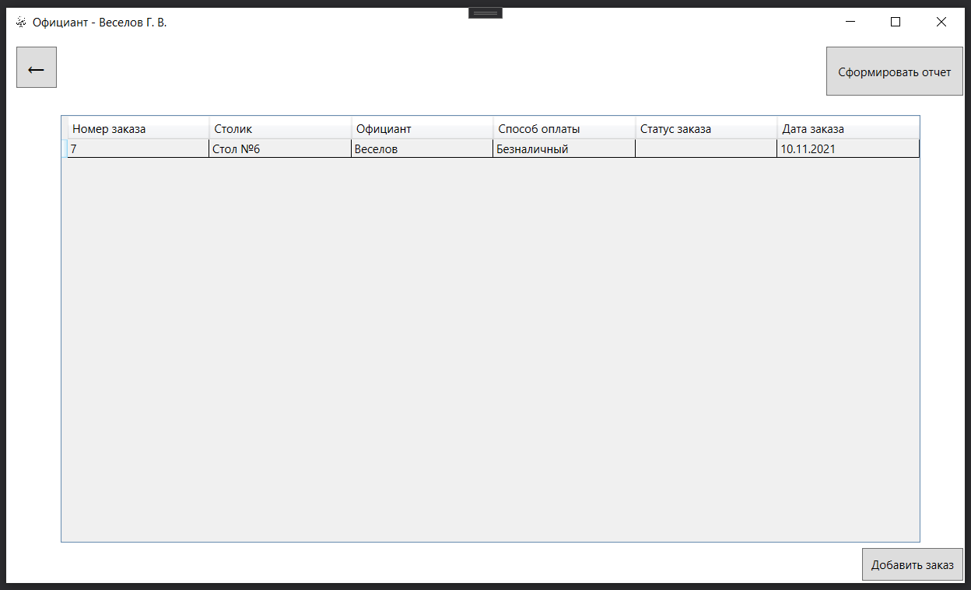
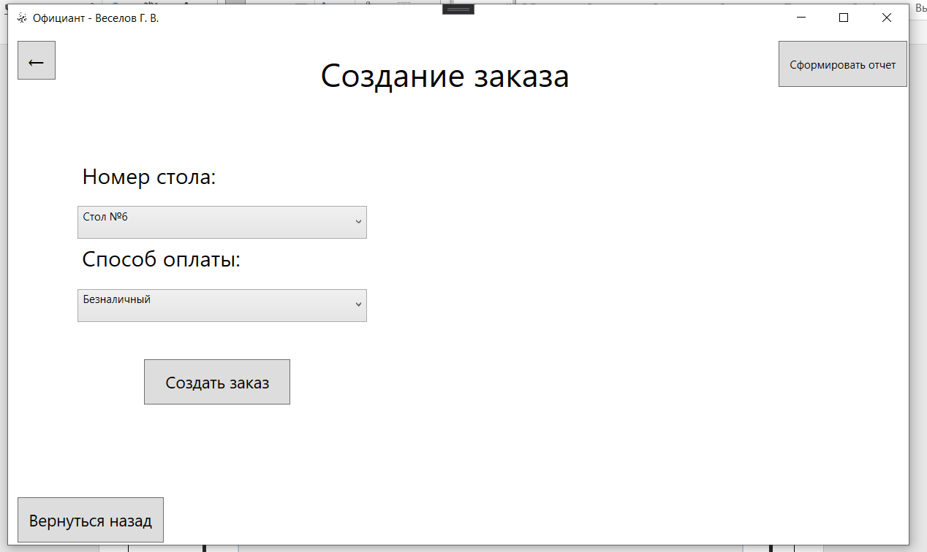
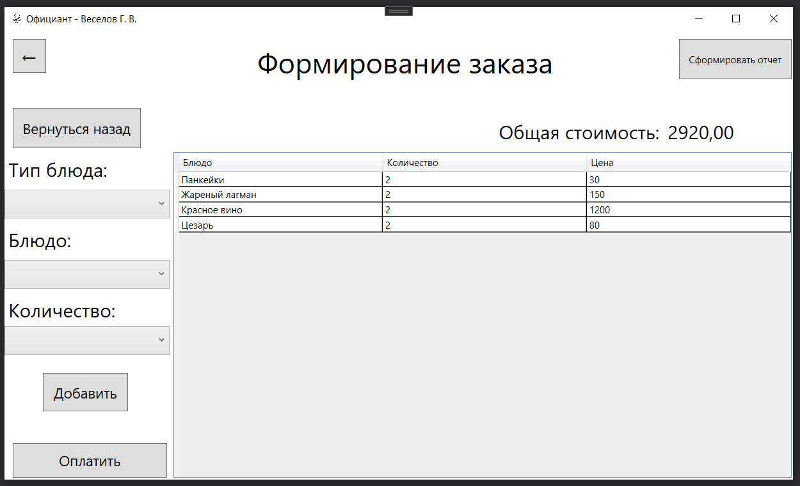
Код:
using Microsoft.Win32;
using System;
using System.Collections.Generic;
using System.Linq;
using System.Text;
using System.Threading.Tasks;
using System.Windows;
using System.Windows.Controls;
using System.Windows.Data;
using System.Windows.Documents;
using System.Windows.Input;
using System.Windows.Media;
using System.Windows.Media.Imaging;
using System.Windows.Shapes;
using Word = Microsoft.Office.Interop.Word;

namespace KAFE
{
/// <summary>
/// Логика взаимодействия для WaiterWindow.xaml
/// </summary>
public partial class WaiterWindow : Window
{
public WaiterWindow()
{
InitializeComponent();
combotable.ItemsSource = Helper.GetContext().Tables.ToList();
combowaypay.ItemsSource = Helper.GetContext().WayPay.ToList();
combofood.ItemsSource = Helper.GetContext().Food.ToList();
combotypefood.ItemsSource = Helper.GetContext().TypeFood.ToList();
var todaysDate = new DateTime(DateTime.Today.Year, DateTime.Today.Month, DateTime.Today.Day);
datagridorder.ItemsSource = Helper.GetContext().Orders.Where(x=>x.DateOrder==todaysDate).ToList();
}

private void btnaddorder_Click(object sender, RoutedEventArgs e)
{
gridaddorder.Visibility = Visibility.Visible;
gridopen.Visibility = Visibility.Hidden;
}

private void backtomainwindow_Click(object sender, RoutedEventArgs e)
{
MainWindow mainWindow = new MainWindow();
mainWindow.Show();
this.Close();
}

private void addorder_Click(object sender, RoutedEventArgs e)
{
DateTime dateTime = DateTime.Now;
var idtable = Helper.GetContext().Tables.FirstOrDefault(x => x.NameTable == combotable.Text);
var idwaypay = Helper.GetContext().WayPay.FirstOrDefault(x => x.NameWayPay == combowaypay.Text);
Orders orders = new Orders
{
ID_Table = idtable.ID_Table,
ID_User = Helper.ID_user,
ID_WayPay = idwaypay.ID_Pay,
ID_Status = 1,
DateOrder = dateTime
};
Helper.GetContext().Orders.Add(orders);
Helper.GetContext().SaveChanges();
gridopen.Visibility = Visibility.Visible;
gridaddorder.Visibility = Visibility.Hidden;
var todaysDate = new DateTime(DateTime.Today.Year, DateTime.Today.Month, DateTime.Today.Day);
datagridorder.ItemsSource = Helper.GetContext().Orders.Where(x=>x.DateOrder==todaysDate).ToList();
MessageBox.Show("Заказ сформирован");
}

private void datagridorder_SelectionChanged(object sender, SelectionChangedEventArgs e)
{
if (datagridorder.SelectedItem is Orders orders)
{
Helper.ID_order = orders.ID_Order;
gridaddorder.Visibility = Visibility.Hidden;
gridopen.Visibility = Visibility.Hidden;
gridaddfood.Visibility = Visibility.Visible;
datagridfoodorder.ItemsSource = Helper.GetContext().ListOrder.Where(x=>x.ID_Order==Helper.ID_order).ToList();
if (Helper.GetContext().ListOrder.Where(x=>x.ID_Order==Helper.ID_order).FirstOrDefault()!=null)
{
decimal sum = Helper.GetContext().ListOrder.Where(x => x.ID_Order == Helper.ID_order).Sum(x => x.Quantity * x.Food.Price);
txtsummoney.Text = String.Format("{0:0.00}", sum);
}
}
}

private void combotypefood_DropDownClosed(object sender, EventArgs e)
{
if (combotypefood.SelectedItem != null)
{
combofood.ItemsSource = Helper.GetContext().Food.Where(x=>x.TypeFood.NameTypeFood==combotypefood.Text).ToList();
}
}

private void btnaddfood_Click(object sender, RoutedEventArgs e)
{
var idstatusorder = Helper.GetContext().Orders.Where(x => x.ID_Order == Helper.ID_order).FirstOrDefault();
if (idstatusorder.ID_Status != 1)
{
MessageBox.Show("Нельзя редактировать содержимое заказа, когда он уже оплачен!");
}
else
{
if (combofood.Text == "" || comboquantity.Text == "")
{
MessageBox.Show("Еда не выбрана!");
}
else
{
var food = Helper.GetContext().Food.Where(x => x.NameFood == combofood.Text).FirstOrDefault();
ListOrder listOrder = new ListOrder
{
ID_Order = Helper.ID_order,
ID_Food = food.ID_Food,
Quantity = Convert.ToInt32(comboquantity.Text)
};
Helper.GetContext().ListOrder.Add(listOrder);
Helper.GetContext().SaveChanges();
datagridfoodorder.ItemsSource = Helper.GetContext().ListOrder.Where(x=>x.ID_Order==Helper.ID_order).ToList();
decimal sum = Helper.GetContext().ListOrder.Where(x => x.ID_Order == Helper.ID_order).Sum(x => x.Quantity * x.Food.Price);
txtsummoney.Text = String.Format("{0:0.00}", sum);
}
}
}

private void datagridfoodorder_SelectionChanged(object sender, SelectionChangedEventArgs e)
{
if (datagridfoodorder.SelectedItem is ListOrder listOrder)
{
var idstatusorder = Helper.GetContext().Orders.Where(x => x.ID_Order == Helper.ID_order).FirstOrDefault();
if (idstatusorder.ID_Status != 1)
{
MessageBox.Show("Нельзя редактировать содержимое заказа, когда он уже оплачен!");
}
else
{
MessageBoxResult result = MessageBox.Show("Вы хотите убрать это блюдо из заказа?", "Информация", MessageBoxButton.YesNo, MessageBoxImage.Question);
switch (result)
{
case MessageBoxResult.Yes:
Helper.GetContext().ListOrder.Remove(listOrder);
Helper.GetContext().SaveChanges();
datagridfoodorder.ItemsSource = Helper.GetContext().ListOrder.ToList();
decimal sum = Helper.GetContext().ListOrder.Where(x => x.ID_Order == Helper.ID_order).Sum(x => x.Quantity * x.Food.Price);
txtsummoney.Text = String.Format("{0:0.00}", sum);
break;
case MessageBoxResult.No:
break;
}
}
}
}

private void btnbuyfood_Click(object sender, RoutedEventArgs e)
{
MessageBoxResult result = MessageBox.Show("Вы хотите распечатать чек? После оплаты заказа, его нельзя будет редактировать!", "Информация", MessageBoxButton.YesNo, MessageBoxImage.Question);
switch (result)
{
case MessageBoxResult.Yes:
var listorders = Helper.GetContext().ListOrder.Where(x => x.ID_Order == Helper.ID_order).ToList();
var orders = Helper.GetContext().Orders.ToList();

SaveFileDialog saveFileDialog = new SaveFileDialog();
saveFileDialog.Title = "Выберите место для сохранения чека";
saveFileDialog.FileName = "Чек" + " - PDF";
saveFileDialog.Filter = "PDF Files |*.pdf";
if (saveFileDialog.ShowDialog() == true)
{
var application = new Word.Application();

Word.Document document = application.Documents.Add();

Word.Paragraph paragraph1 = document.Paragraphs.Add();
Word.Range range1 = paragraph1.Range;
range1.Text = "Чек из \"Alberto Del Rio\"";
paragraph1.set_Style("Заголовок");
range1.Font.Size = 18;
range1.InsertParagraphAfter();

Word.Paragraph paragraph2 = document.Paragraphs.Add();
Word.Range range2 = paragraph2.Range;
range2.Text = "Дата и время: " + DateTime.Now;
paragraph2.set_Style("Заголовок");
range2.Font.Size = 18;
range2.InsertParagraphAfter();

var sposobpayway = Helper.GetContext().Orders.Where(x => x.ID_Order == Helper.ID_order).FirstOrDefault();
Word.Paragraph paragraph7 = document.Paragraphs.Add();
Word.Range range7 = paragraph7.Range;
range7.Text = "Способ оплаты: " + sposobpayway.WayPay.NameWayPay;
paragraph7.set_Style("Заголовок");
range7.Font.Size = 18;
range7.InsertParagraphAfter();

Word.Paragraph paragraph4 = document.Paragraphs.Add();
Word.Range cellrange = paragraph4.Range;
Word.InlineShape inlineShape = cellrange.InlineShapes.AddPicture(@"C:\Users\Acer\Desktop\KAFE\KAFE\Images\logo.png");
inlineShape.Width = inlineShape.Height = 200;
paragraph4.Alignment = Word.WdParagraphAlignment.wdAlignParagraphCenter;
cellrange.InsertParagraphAfter();

Word.Paragraph paragraph3 = document.Paragraphs.Add();
Word.Range range3 = paragraph3.Range;
range3.Text = "Перечень продуктов";
paragraph3.set_Style("Выделенная цитата");
range3.Font.Size = 18;
range3.Font.Color = Word.WdColor.wdColorBlack;
range3.InsertParagraphAfter();

foreach (var lisord in listorders)
{
Word.Paragraph paragraph = document.Paragraphs.Add();
Word.Range range = paragraph.Range;
range.Text = "| " + lisord.Food.NameFood + " x " + lisord.Quantity + " - " + lisord.Food.Price.ToString("0.00") + " руб. |";
paragraph.set_Style("Обычный");
range.Font.Size = 14;
range.InsertParagraphAfter();

//Word.Paragraph tableparagraph = document.Paragraphs.Add();
//Word.Range tablerange = tableparagraph.Range;
//Word.Table table = document.Tables.Add(tablerange, orders.Count() + 1, 3);
//table.Borders.InsideLineStyle = table.Borders.OutsideLineStyle = Word.WdLineStyle.wdLineStyleSingle;
//table.Range.Cells.VerticalAlignment = Word.WdCellVerticalAlignment.wdCellAlignVerticalCenter;

//Word.Range cellrange;

}

Word.Paragraph paragraph5 = document.Paragraphs.Add();
Word.Range range5 = paragraph5.Range;
range5.Text = "Всего: " + txtsummoney.Text + " руб.";
paragraph5.set_Style("Выделенная цитата");
range5.Font.Size = 24;
range5.Font.Color = Word.WdColor.wdColorRed;
range5.Bold = 5;
range5.InsertParagraphAfter();

//application.Visible = true;

document.SaveAs2(saveFileDialog.FileName, Word.WdExportFormat.wdExportFormatPDF);
//application.Quit();

//document.SaveAs2(@"C:\Users\Acer\Desktop\Test.docx");
//document.SaveAs2(@"C:\Users\Acer\Desktop\Test.pdf", Word.WdExportFormat.wdExportFormatPDF);
}

//Обновление статуса заказа
var buyorders = Helper.GetContext().Orders.Where(x => x.ID_Order == Helper.ID_order).FirstOrDefault();
if (buyorders.ID_Status==1)
{
buyorders.ID_Status = 2;
}
Helper.GetContext().SaveChanges();

var idcheck = Helper.GetContext().Check.Where(x => x.ID_Order == Helper.ID_order).FirstOrDefault();

if (idcheck == null)
{
//Добавление в Чек-таблицу
Check check = new Check
{
ID_Order = Helper.ID_order,
DateCheck = DateTime.Now,
TotalPrice = Convert.ToDecimal(txtsummoney.Text)
};
Helper.GetContext().Check.Add(check);
Helper.GetContext().SaveChanges();
}

var todaysDate = new DateTime(DateTime.Today.Year, DateTime.Today.Month, DateTime.Today.Day);
datagridorder.ItemsSource = Helper.GetContext().Orders.Where(x=>x.DateOrder==todaysDate).ToList();
txtsummoney.Text = "";
gridaddfood.Visibility = Visibility.Hidden;
gridopen.Visibility = Visibility.Visible;
break;
case MessageBoxResult.No:
break;
}
}

private void backtopenorder_Click(object sender, RoutedEventArgs e)
{
if (gridaddorder.Visibility == Visibility.Visible || gridaddfood.Visibility == Visibility.Visible)
{
gridaddfood.Visibility = Visibility.Hidden;
gridaddorder.Visibility = Visibility.Hidden;
gridopen.Visibility = Visibility.Visible;
}
}

private void btnreport_Click(object sender, RoutedEventArgs e)
{
var user = Helper.GetContext().Users.Where(x => x.ID_User == Helper.ID_user).FirstOrDefault();
ReportWaiter reportWaiter = new ReportWaiter();
reportWaiter.Title = "Отчета за смену - " + user.LastName;
reportWaiter.ShowDialog();
}
}
}

Окно ReportWaiter (Окно отчета официанта):
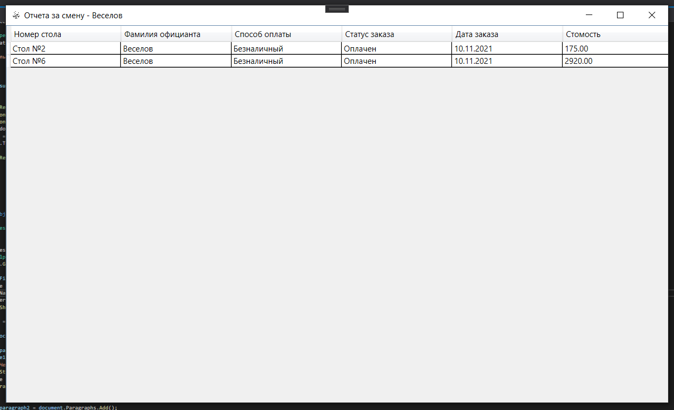
Код:
using System;
using System.Collections.Generic;
using System.Data;
using System.Data.SqlClient;
using System.Linq;
using System.Text;
using System.Threading.Tasks;
using System.Windows;
using System.Windows.Controls;
using System.Windows.Data;
using System.Windows.Documents;
using System.Windows.Input;
using System.Windows.Media;
using System.Windows.Media.Imaging;
using System.Windows.Shapes;

namespace KAFE
{
/// <summary>
/// Логика взаимодействия для ReportWaiter.xaml
/// </summary>
public partial class ReportWaiter : Window
{

SqlConnection con = new SqlConnection("Data Source=localhost;Initial Catalog=Cafe;Integrated Security=True");

public ReportWaiter()
{
InitializeComponent();
}

private void Window_Loaded(object sender, RoutedEventArgs e)
{
Button_Click(sender, e);
}

private void Button_Click(object sender, RoutedEventArgs e)
{
var todaysDate = new DateTime(DateTime.Today.Year, DateTime.Today.Month, DateTime.Today.Day);
con.Open();
string sql = "SELECT [Tables].NameTable,Users.LastName,WayPay.NameWayPay,StatusOrder.NameStatusOrder,DateOrder,Sum(Food.Price*ListOrder.Quantity) FROM Orders " +
"inner join Users on Orders.ID_User = Users.ID_User inner join[Tables] on Orders.ID_Table = [Tables].ID_Table inner join WayPay on Orders.ID_WayPay = WayPay.ID_Pay " +
"inner join StatusOrder on Orders.ID_Status = StatusOrder.ID_StatusOrder inner join ListOrder on Orders.ID_Order = ListOrder.ID_Order inner join Food on ListOrder.ID_Food = Food.ID_Food " +
"group by[Tables].NameTable,Users.LastName,WayPay.NameWayPay,StatusOrder.NameStatusOrder,DateOrder,Users.ID_User Having Orders.DateOrder = '" + todaysDate+ "' AND Users.ID_User='"+Helper.ID_user+"'";
SqlDataAdapter dataAdapter = new SqlDataAdapter(sql, con);
DataTable data = new DataTable("Orders");
dataAdapter.Fill(data);
datagridreport.ItemsSource = data.DefaultView;
dataAdapter.Update(data);
con.Close();
datagridreport.Columns[0].Header = "Номер стола";
datagridreport.Columns[1].Header = "Фамилия официанта";
datagridreport.Columns[2].Header = "Способ оплаты";
datagridreport.Columns[3].Header = "Статус заказа";
datagridreport.Columns[4].Header = "Дата заказа";
datagridreport.Columns[5].Header = "Стомость";
(datagridreport.Columns[4] as DataGridTextColumn).Binding.StringFormat = "dd.MM.yyyy";
(datagridreport.Columns[5] as DataGridTextColumn).Binding.StringFormat = "0.00";

}
}
}

Окно CookWindow (Окно повара):
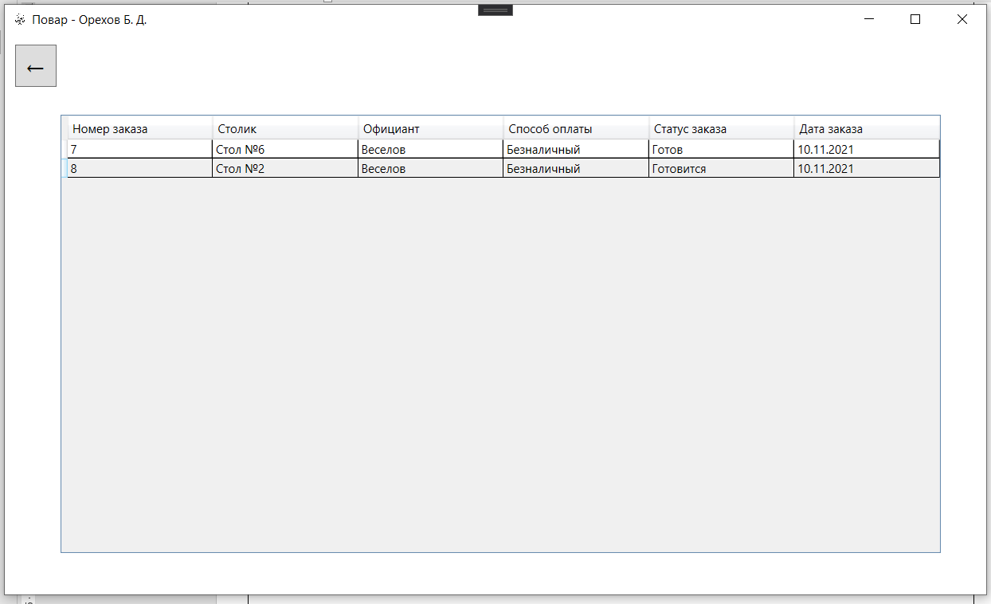
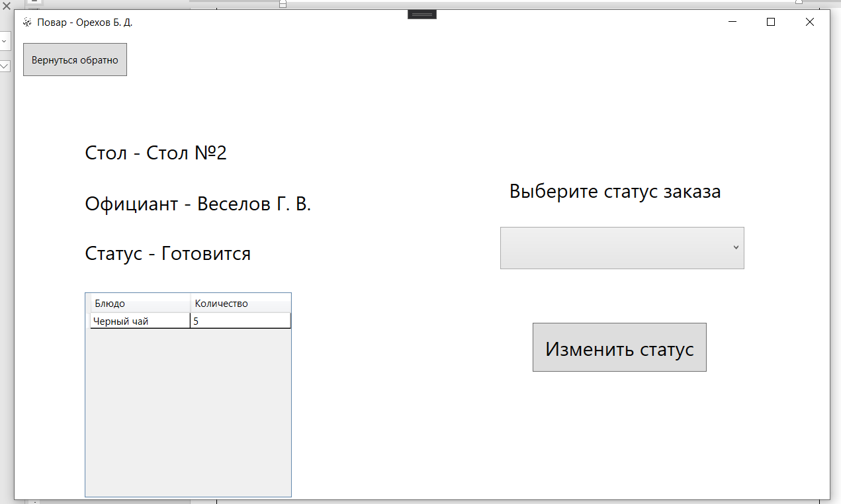
Код:
using System;
using System.Collections.Generic;
using System.Linq;
using System.Text;
using System.Threading.Tasks;
using System.Windows;
using System.Windows.Controls;
using System.Windows.Data;
using System.Windows.Documents;
using System.Windows.Input;
using System.Windows.Media;
using System.Windows.Media.Imaging;
using System.Windows.Shapes;

namespace KAFE
{
/// <summary>
/// Логика взаимодействия для CookWindow.xaml
/// </summary>
public partial class CookWindow : Window
{
public CookWindow()
{
InitializeComponent();
var todaysDate = new DateTime(DateTime.Today.Year, DateTime.Today.Month, DateTime.Today.Day);
datagridorder.ItemsSource = Helper.GetContext().Orders.Where(x => x.ID_Status != 1&&x.DateOrder==todaysDate).ToList();
}

int idstatus = 2;

private void backtomainwindow_Click(object sender, RoutedEventArgs e)
{
MainWindow mainWindow = new MainWindow();
mainWindow.Show();
this.Close();
}

private void datagridorder_SelectionChanged(object sender, SelectionChangedEventArgs e)
{
if (datagridorder.SelectedItem is Orders orders)
{
Helper.ID_order = orders.ID_Order;
gridstatus.Visibility = Visibility.Visible;
txtstatus.Text = "Статус - " + orders.StatusOrder.NameStatusOrder;
txttable.Text = "Стол - " + orders.Tables.NameTable;
txtwaiter.Text = "Официант - " + orders.Users.LastName +" " + orders.Users.FirstName.Substring(0,1)+". " + orders.Users.MiddleName.Substring(0,1)+".";
datagridfoodorder.ItemsSource = Helper.GetContext().ListOrder.Where(x => x.ID_Order == Helper.ID_order).ToList();
if (orders.ID_Status == 2)
{
combostatus.Items.Add("Готовится");
idstatus = 3;
}
else if (orders.ID_Status == 3)
{
combostatus.Items.Add("Готов");
idstatus = 4;
}
else
{
gridstatus.Visibility = Visibility.Hidden;
MessageBox.Show("Заказ уже готов!");
}
}
}

private void savestatus_Click(object sender, RoutedEventArgs e)
{
gridstatus.Visibility = Visibility.Hidden;
combostatus.Items.Clear();
var update = Helper.GetContext().Orders.Where(x => x.ID_Order == Helper.ID_order).FirstOrDefault();
update.ID_Status = idstatus;
Helper.GetContext().SaveChanges();
var todaysDate = new DateTime(DateTime.Today.Year, DateTime.Today.Month, DateTime.Today.Day);
datagridorder.ItemsSource = Helper.GetContext().Orders.Where(x => x.ID_Status != 1&&x.DateOrder==todaysDate).ToList();
}

private void btntoback_Click(object sender, RoutedEventArgs e)
{
gridstatus.Visibility = Visibility.Hidden;
}
}
}

Класс Helper:
Код:
using System;
using System.Collections.Generic;
using System.Linq;
using System.Text;
using System.Threading.Tasks;

namespace KAFE
{
public class Helper
{
private static CafeEntities _context;
public static CafeEntities GetContext()
{
if (_context == null)
{
_context = new CafeEntities();
}
return _context;
}
public static int ID_user;
public static int ID_order;
}
}

Ссылка на GitHub:
https://github.com/petrbihteev/KAFE.git

